PDC Lab 7
Advait Deochakke
20BCE1143
Q1 ) Parallel – nowait

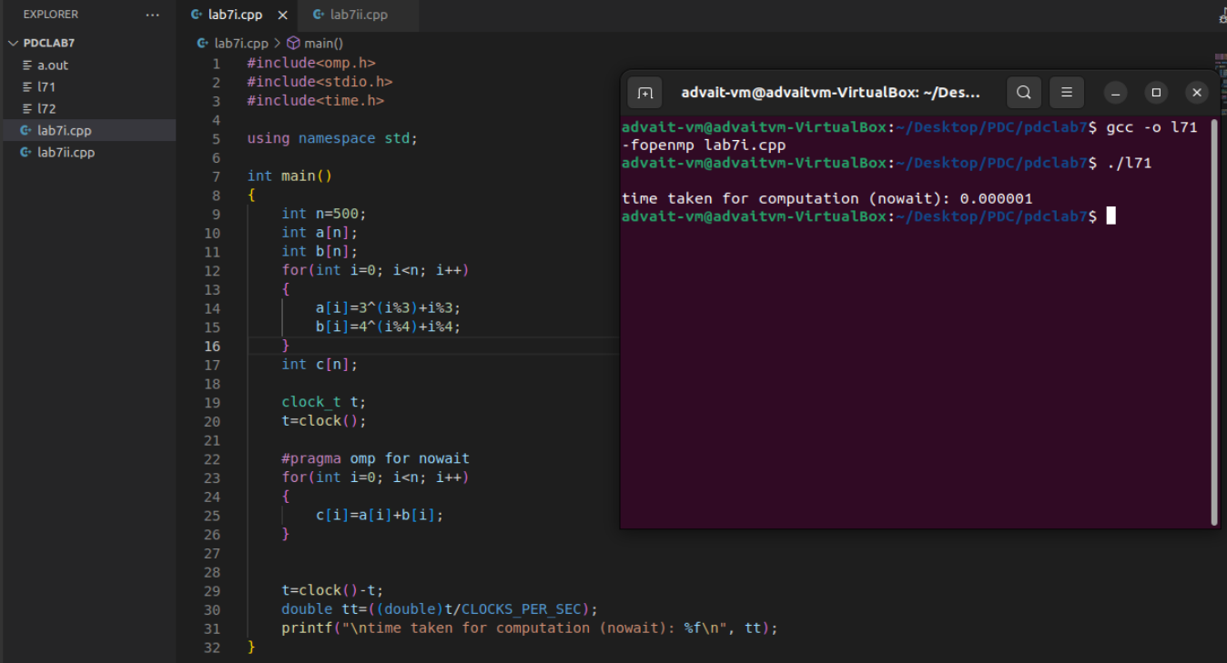
Code:

#include<omp.h>
#include<stdio.h>
#include<time.h>

using namespace std;

int main()
{
int n=500;
int a[n];
int b[n];
for(int i=0; i<n; i++)
{
a[i]=3^(i%3)+i%3;
b[i]=4^(i%4)+i%4;
}
int c[n];

clock_t t;
t=clock();

#pragma omp for nowait
for(int i=0; i<n; i++)
{
c[i]=a[i]+b[i];
}

t=clock()-t;
double tt=((double)t/CLOCKS_PER_SEC);
printf("\ntime taken for computation (nowait): %f\n", tt);
}

Q2 ) Parallel – Barrier

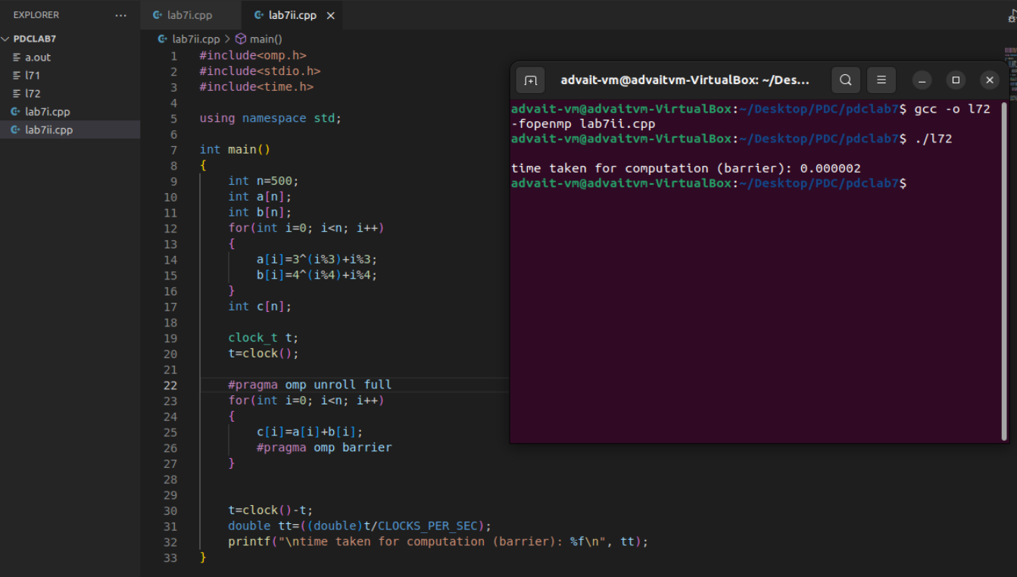

Code:

#include<omp.h>
#include<stdio.h>
#include<time.h>

using namespace std;

int main()
{
int n=500;
int a[n];
int b[n];
for(int i=0; i<n; i++)
{
a[i]=3^(i%3)+i%3;
b[i]=4^(i%4)+i%4;
}
int c[n];

clock_t t;
t=clock();

#pragma omp unroll full
for(int i=0; i<n; i++)
{
c[i]=a[i]+b[i];
#pragma omp barrier
}

t=clock()-t;
double tt=((double)t/CLOCKS_PER_SEC);
printf("\ntime taken for computation (barrier): %f\n", tt);
}

